**Completing a Convergence Study on the Triangular Drum**

A fine, regular mesh will require less refining to reach convergence than a coarser, irregular mesh. Since gmsh meshed the circular mesh finely and regularly initially, there was limited convergence results. However, the triangular shape had a significantly coarser mesh, and had some irregularities as well, so the reported convergence results are for the triangular drum head.

The node count and element count for the mesh is shown in the table below. The output from Julia seems to have a clear pattern where the theoretical node count is a factor of 4 larger or smaller than the adjacent refinement level (excluding initial mesh). Similarly, the theoretical element count is consistently twice as large as the node count. The theoretical values are close to the actual values.

|  |  |  |  |  |  |  |
| --- | --- | --- | --- | --- | --- | --- |
|  | julia | | | | mathematica | |
| refinement | nodes | theoretical nodes | elements | theoretical elements | elements | dimension^2 |
| 0 | 177 | 161.25 | 355 | 322.5 | 786 | 126 |
| 1 | 645 | 645 | 1288 | 1290 | 3681 | 555 |
| 2 | 2481 | 2580 | 4960 | 5160 | 15669 | 2295 |
| 3 | 9729 | 10320 | 19456 | 20640 | 64677 | 9351 |

This figure shows the initial and refined meshes. The irregularities of the meshes become quite obvious when looking at the refined mesh, since the pattern and size of the elements is clearly different from the rest of the mesh. Only 3 refinements were done after the initial mesh due to computation time of the meshes eigenvalues.

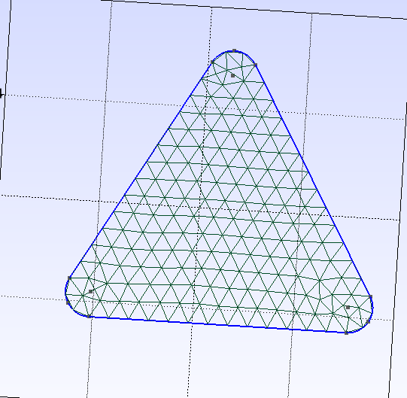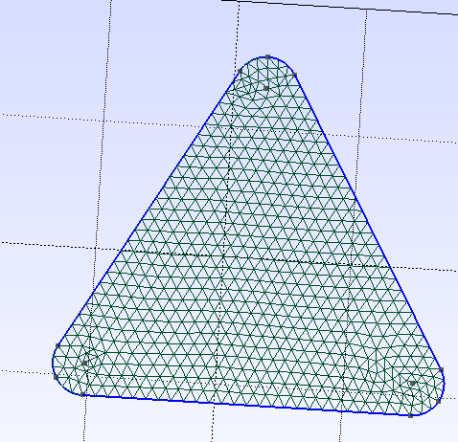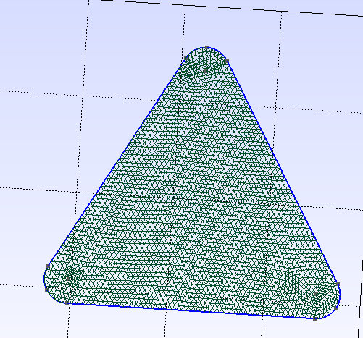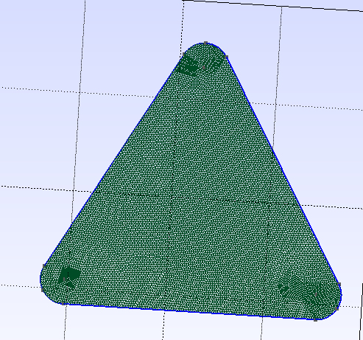

Initial Mesh

Refinement 1

Refinement 2

Refinement 3

The percent change in the lowest 6 Eigenvalues from refining the mesh can be seen in the chart. This chart shows that after the first iteration, the eigenvalue changed between 1 and 4 percent. However, after the first iteration, the percent change dropped to less than 1, and then less than 0.25.

The table below shows the eigenvalues and the percent change. Similarly to the line chart, it shows a decreasing eigenvalue change as it becomes more refined. Additionally, the lower eigenvalues had less change from the refined mesh than the higher eigenvalues.

|  |  |  |  |  |  |  |  |  |  |  |  |  |
| --- | --- | --- | --- | --- | --- | --- | --- | --- | --- | --- | --- | --- |
|  | Eigenvalue 6 | | Eigenvalue 5 | | Eigenvalue 4 | | Eigenvalue 3 | | Eigenvalue 2 | | Eigenvalue 1 | |
| Refinement | value | %change | value | %change | value | %change | value | %change | value | %change | value | %change |
| 0 | 0.876 |  | 0.875 |  | 0.805 |  | 0.461 |  | 0.460 |  | 0.194 |  |
| 1 | 0.842 | 3.972 | 0.842 | 3.949 | 0.776 | 3.782 | 0.451 | 2.100 | 0.451 | 2.097 | 0.193 | 0.876 |
| 2 | 0.836 | 0.767 | 0.836 | 0.755 | 0.772 | 0.504 | 0.449 | 0.401 | 0.449 | 0.395 | 0.192 | 0.183 |
| 3 | 0.834 | 0.197 | 0.834 | 0.194 | 0.771 | 0.137 | 0.449 | 0.102 | 0.449 | 0.101 | 0.192 | 0.046 |